

Keeping your home

Free from

Condensation and

Mould Growth

KEEPING OUT DAMP AND MOULD

THIS INFORMATION SHEET EXPLAINS HOW DAMAGE CAN OCCUR IN YOUR HOME FROM DAMP AND MOULD AND WHAT YOU CAN DO TO REDUCE AND HELP TO PREVENT IT

If your home is damp, it can cause mould on your walls and furniture and rot wooden window frames. A damp home encourages mites and increases the risk of respiratory illness.

There will always be some moisture in the air. When the air gets colder it cannot hold all the moisture and tiny droplets of water will appear.

This is condensation and it is a major cause of damp. You may have noticed it when you breathe on a cold day or when the mirror mists over when you run a bath. It appears on cold surfaces and in places where there is little air movement so you should check in corners, on or around windows and behind wardrobes and cupboards. Sometimes there is a musty smell.

Although condensation is a major cause of damp, it can also come from:

- Leaking Pipes, waste or overflows

- Rain getting through holes in roofs, spilling from a blocked gutter, penetrating around window frames or leaking through a cracked pipe

- Rising damp because of a faulty damp course

- If your home is newly built, it could be damp because water used in plaster during its construction for example, is still drying out

If your home is damp for any of these reasons, please notify the CO-OP office and an officer will make an appointment to inspect and recommend remedial works
Insulation and Draught proofing

Insulation and draught proofing will help keep your home warm and cut fuel bills. When the whole home is warmer, condensation is less likely.

Heating your home

In cold weather, keep low background heating on all day even when no one is at home. The Co-op appreciate that heating your home can be costly and that keeping heating on when you are out could appear wasteful, but if it is at a median level the boiler will not have to work as hard to reheat the home.

Treatment of mould

Where there is mould you can treat it very easily.

To kill and remove mould, wipe down walls and window frames with a fungicidal wash, following the instructions precisely. These are available from most supermarkets.
Dry-clean mildewed clothes and shampoo carpets.

It is not a good idea to disturb mould by brushing or vacuuming as this can increase the risk of respiratory problems.

After washing down surfaces as described above, these can be painted with a good quality fungicidal paint.

Caution

- Do not block permanent wall ventilators in rooms
- Do not completely block chimneys
- If there is a louvered grill, do not cover it
- Do not draught proof rooms where there is condensation or mould
- Do not draught proof rooms where there is a cooker or fuel burning heater
- Do not draught proof windows in the bathroom or kitchen

How can you avoid damp and condensation?

Produce less moisture

- cover pans when cooking and do not leave kettles boiling

- do not use calor gas heaters as these put a lot of moisture in the air (please note that it is a part of your tenancy/lease not to use calor gas heaters or bottled gas heaters anywhere in your home)

- dry washing outside (balcony) on a line or in the bathroom with the door closed and a window open or the extractor fan on

- ensure that you vent your tumble dryer directly to the outside

- switch extractor fans on where you have them

Ventilate so that moisture can escape

- keep a small window ajar or trickle ventilator open when someone is in the room

- ventilate kitchens and bathrooms when in use by opening the
window

- ventilate cupboards and wardrobes and avoid filling them too much, as this will prevent air from circulating.

- leave a space between the wardrobe and the wall

GENERAL INFORMATION FOR TENANTS

What is condensation?

Condensation is dampness that comes from water vapour in the air.

It occurs to some degree in all homes but if left unchecked, it can become a serious problem.

There is always some moisture in the air, even if you cannot see it. Lots of extra moisture is created by everyday activities such as cooking, washing clothes and bathing. Even asleep one person generates about half a litre of water in a night just from breathing and perspiration.

Warm air can hold more moisture longer than cold air. If the air gets colder it cannot hold all the moisture and tiny droplets of water appear. You notice it when you see your breath on a cold day or when the mirror mists over when you have a bath.

Condensation often happens because warm damp air from kitchens and bathrooms circulates into colder areas such as bedrooms. It occurs in cold weather whether it is raining or dry

Condensation typically appears on cold surfaces and in places where there is little air movement such as in corners, on or near windows or in and behind wardrobes and cupboards. The appearance of mould in these areas is often the first sign of a serious condensation problem

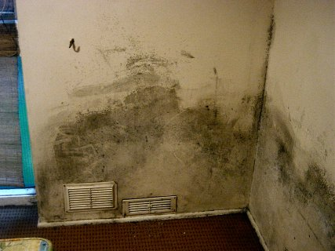

Causes of condensation

The degree to which condensation occurs in your home depends on four factors:

- How much moisture is generated within your home

- The amount of ventilation

- How well your home is insulated

- The temperature in your home

All these factors need to be looked at to cure a condensation problem

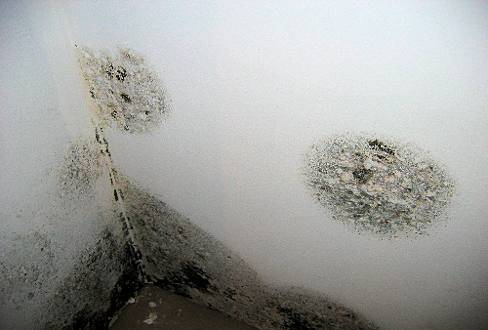

Preventing condensation

It is important to take steps to keep condensation under control.
Too much condensation will make your home damp and unhealthy. House dust mites and moulds occur more in damp conditions and these are associated with allergic reactions.

Damp conditions can also cause damage to your home such as by causing windows to rust or rot, and plaster to perish. Decorations can be spoilt by damp and mould growth.

Both the council, as your landlord and you as the tenant, are responsible for keeping condensation under control.

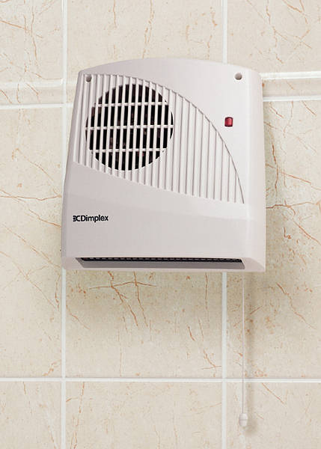
The Tenant’s responsibilities

Reducing moisture production

- When cooking, cover pans with lids and keep the kitchen door closed to stop wet air from circulating around your dwelling. Make sure that a window is open or the extractor fan is on

- If you use a tumble, dryer make sure it is vented to the outside

- If you have to dry clothes indoors ideally put them in the bathroom with the door closed and the window open or fan on. Alternatively put them on a clothes dryer in another room but make sure the door to the room is closed and the windows are open

- When bathing, run cold water into the bath first and then run the hot water. This will minimise steam production

Heating your home

- Heat all rooms even if they are not being used

- Do not place furniture or belongings in front of radiators as this will stop them heating the room efficiently

- Do not use portable LPG (Calor Gas) heaters. These can produce three (3) pints of moisture in five hours and are prohibited in our homes for health and safety reasons

- Do not use the heating on a high setting for short periods of time. Heating your home for longer time at a lower temperature will keep your home warmer and cost you less

- If you have central heating, use the thermostat to control the heating by setting the temperature to a comfortable level. The recommend temperature is 18 degrees C in your hall and 21 degrees C in your hall and 21 degrees C in your living room (or up to 23 degrees c, if you have young children or are a pensioner)

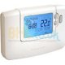 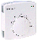

- If your radiators have Thermostatic Radiator Valves (TRVs), these will give you greater control over the heat from each individual radiator
If you need further advice about setting your thermostat and room temperature, contact the Co-op so that we can make arrangement for an Energy Advisor to visit you.

The energy team can also provide assistance with draught proofing and other insulation measures.

Ventilating your home

It is important to allow plenty of fresh air into your homes as the indoor air will become stale and humid, leading to unhealthy conditions.

- Always keep a small window ajar or a vent open when someone is in the room. It is best to keep vents open all the time.

- After you have had a bath or shower you need to open the bathroom window for a while until the steam has cleared or alternatively use the extractor fan if you have one.

- When cooking make sure that the kitchen door is closed and either the extractor fan is on (if you have one) or a window is open

- Do not switch off or tamper with any ventilation equipment provided in your home

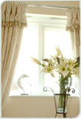

Some of our homes are fitted with extractor fans. These are used to quickly remove damp air form the kitchen and bathroom where the most moisture is produced.

- Fans should be used whenever you are cooking or bathing. After you have finished in the bathroom or the kitchen leave the fan on for about 20 minutes to ensure that all damp air is cleared

Looking after your home

- An extractor fan will only work if the windows in the room are kept closed. If a window is open the fan will draw air in from outside rather than drawing out the damp air from the room

- Some fans switch on and off automatically according to the amount of moisture in the air. Do not turn these off at the power switch as they are designed to work when they are needed. If you suspect that they are coming on more or less often than they should, then you need to report this to the Co-op. If you do not have an extractor fan, please let the
Co-op know

Looking after your home

- Wipe down the inside of windows if they become wet with condensation

- Try not to place beds and wardrobes against outside walls as mould is more likely to grow behind furniture

- Don’t put too many things in wardrobes and cupboards as it stops the air circulating

- Remove small patches of mould that may appear on surfaces using one of the mould cleaning products suitable for that purpose. These are obtainable from supermarkets. Make sure that you use as product which carries a Health and Safety Executive ‘approval number’ and that you follow the manufacture’s instructions

- When redecorating bathrooms and kitchens, use a paint formulated for these areas

- Do not decorate over walls or ceilings that have been decorated using fungicidal paint with ordinary paints or wallpapers

- Report any repairs to the Co-op Office

The Council’s and the Co-op’s responsibilities

The council as your landlord has to meet certain obligations with regards to the structure of your home and the facilities provided.

- To make reasonable provision for heating

- To ensure there is reasonable thermal insulation to the structure of the dwelling

- To make provision for ventilation, such as to provide extractor fans and air vents where appropriate

- To carry out any repairs to your home in accordance with the council’s repairing obligations. Such as to ensure extractor fans and heating systems are in working order. That there are no other sources of dampness, due to plumbing or rainwater leaks

The council will consider carrying out remedial works for condensation and mould growth only when all the criteria below have been met:

- Where the condensation and mould growth is significant and presents a hazard to health

- Where the problem is due to insufficient facilities for heating, ventilation or poor thermal insulation

- Where you as the householder have followed the advice given in this document and have taken all reasonable steps to prevent the problem occurring

Please contact the Co-op Office when you have a query on any repair aspect as above.

Please ensure that you follow all of the steps in this document to minimise condensation

