**Co-op Membership**

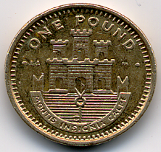

All leaseholders and tenants are welcome to join Kilburn Square Housing Co-operative membership. Membership is £1.00 each. If you are a Co-op member you can attend General Meetings and Annual General Meetings and you can voice your opinions on matters. Have your say on the running of the estate and receive a discount price for events by Kilburn Square. Please note leaseholders sub-tenants cannot become a member.